 | Product | Description | Total | DFW | SEA
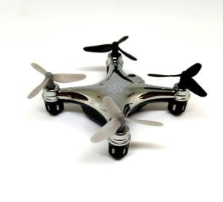 | HS-1954 | ATOM 1.0 MICRO DRONE - INDOOR/OUTDOOR  WIRELESS QUADROCOPTER | 216 | 216
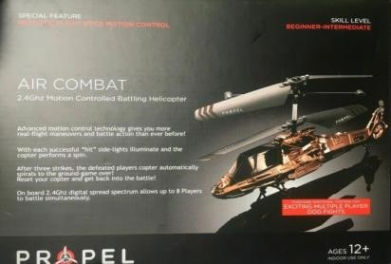 | HS-1933 | AIR COMBAT - 2.4 GHZ MOTION CONTROLLED  BATTLING HELICOPTER TITANIUM/RED | 410 | 410
 | HS-1936 | AIR COMBAT - 2.4 GHZ MOTION CONTROLLED  BATTLING HELICOPTER BLUE/GOLD | 300 | 300
 | HS-1943 | MEUTRON | 930 | 930
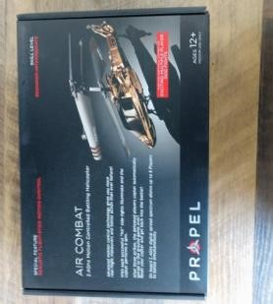 | HS-1953 | AIR COMBAT - 2.4 GHZ MOTION CONTROLLED  BATTLING HELICOPTER | 481 | 481
 | HS-1956 | SKY RAIDER - 2.4 GHZ INDOOR/OUTDOOR  BATTLING QUADROCOPTER | 333 | 333
 | HS-1957 | SKY RAIDER - 2.4 GHZ INDOOR/OUTDOOR  BATTLING QUADROCOPTER | 40 | 40
 | HS-1958 | SKY RAIDER - 2.4 GHZ INDOOR/OUTDOOR  BATTLING QUADROCOPTER | 368 | 368
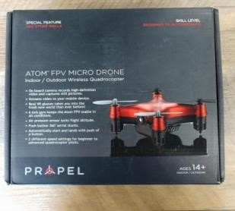 | HS-2405 | ATOM FPV MICRO DRONE - INDOOR/OUTDOOR  WIRELESS QUADROCOPTER | 656 | 368
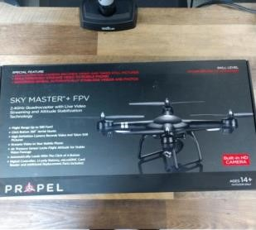 | HS-2409 | SKY MASTER + FPV - 2.4 GHZ BLUE QUADROCOPTER W/ LIVE VIDEO STREAMING | 34 | 34
 | HS-2412 | ORBIT HD BLACK - 2.4 GHZ QUADROCOPTER W/  HD CAMERA | 249 | 249
 | HS-2413 | ORBIT HD GREEN - 2.4 GHZ QUADROCOPTER W/  HD CAMERA | 187 | 187
 | HS-2414 | ORBIT HD, 508936404 | 290 | 290

 | HS-2416 | ORBIT HD RED - 2.4 GHZ QUADROCOPTER W/ HD  CAMERA | 486 | 486
 | HS-2418 | ORBIT HD - 2.4 GHZ QUADROPCOPTER W/ HD  CAMERA | 45 | 45
 | HS-2422 | PROTON MICRO DRONE - INDOOR/OUTDOOR  WIRELESS QUADROCOPTER | 378 | 378
 | HS-2425 | PROTON MICRO DRONE | 452 | 452
 | HS-2432 | SKY FORCE | 170 | 170
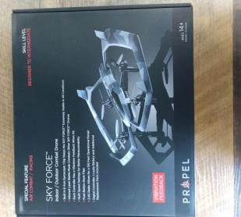 | HS-2433 | SKY FORCE | 878 | 878
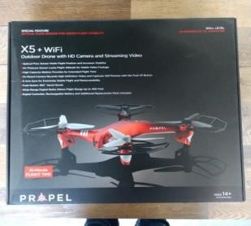 | HS-2436 | XS T WIFI | 24 | 24
 | HS-2438 | PROPEL GROVITIONAND WIFI | 196 | 196
 | HS-2443 | GRAVITON+WIFI | 275 | 275
 | HS-2445 | ZIPPO NANA X2 | 505 | 505
 | HS-2447 | ZIPP NANO X2 | 297 | 297
 | HS-2448-B | ZIPP NANO X2 BLACK | 200 | 200
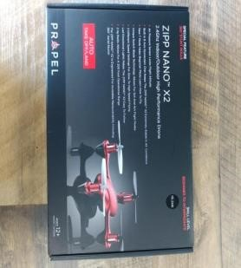 | HS-2448-R | ZIPP NANO X2 RED | 560 | 560
 | HS-2450 | ZIPP NANO | 388 | 388
 | HS-2452 | AIR COMBAT | 145 | 145
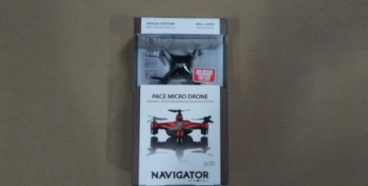 | NV-3820 | NAVIGATOR PACE MICRO DRONE | 7682 |  | 7682
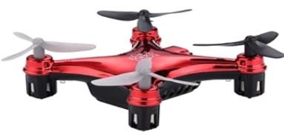 | OD-2101 | ATOM MICRO DRONE RED | 8 |  | 8

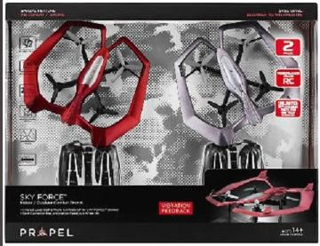 | OD-2108 | PROPEL SKY FORCE 2 PACK BATTLING DRONES ASSORTMENT | 12 |  | 12
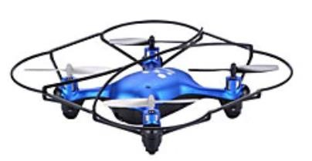 | OD-2111 | NEUTRON BLUE | 91 |  | 91
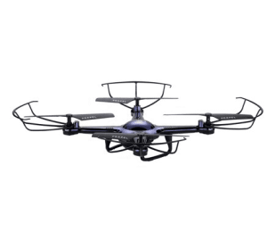 | OD-2113 | SKYRIDER BLUE + EXTRA BATTERY | 1128 |  | 1128
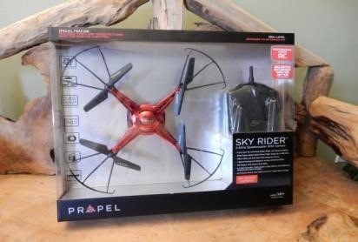 | OD-2114 | SKYRIDER RED + EXTRA BATTERY | 2042 |  | 2042
 | PL-1350 | PL-1351/1352/1354/1355 PROPEL PROTON MICRO  DRONE ASSORTMENT | 100 | 100
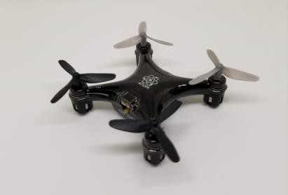 | PL-1390 | ATOM 1.0 MICRO DRONE | 1880 | 1880
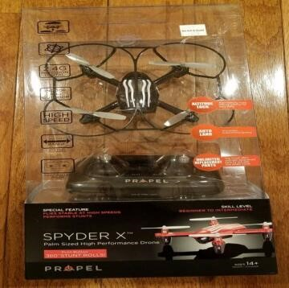 | PL-1400 | SPYDER | 4746 | 4746

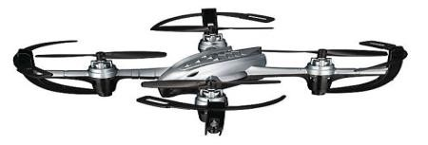 | PL-1402 | SPYDER STUNT DRONE-28MC/PLT | 5050 | 5050
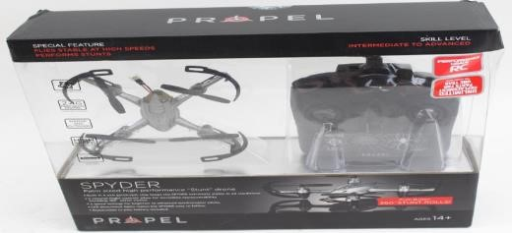 | PL-1434 | CLOUD RIDER | 85 | 85
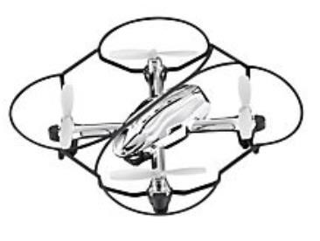 | PL-1483 | SPYDER X | 86 | 86
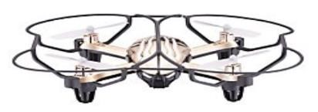 | PL-1486 | SPYDER ROOFTOP BRANDS | 156 | 156
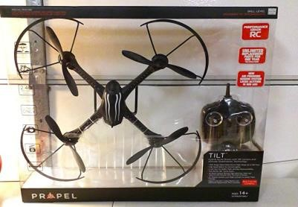 | PL-1530* | DRONE | 1865 | 1865
 | PL-1530-SP | Tilt Complete w/spare parts | 47 | 47
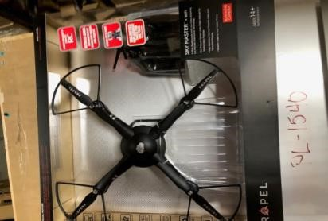 | PL-1540 | SKY MASTER WHOLE SET | 33 |  | 33
 | PL-1601 |  | 20 |  | 20
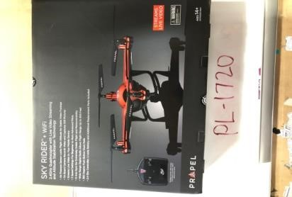 | PL-1720 | SKY RIDER FPV COMPLETE SET TITANIUM | 546 |  | 546
 | PL-1763-R | TUNNEL PALM DRONE RED 7379565 | 32 |  | 32
 | PL-1770 | MOVE (1318531) | 2 |  | 2

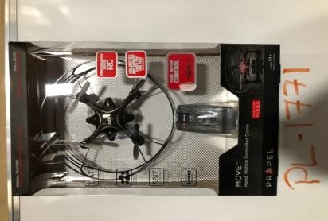 | PL-1771 | MOVE DRONE - GREEN | 292 |  | 292
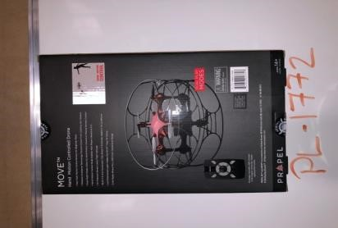 | PL-1772 | MOVE DRONE - RED | 301 |  | 301
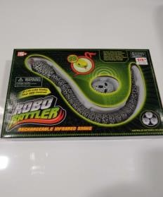 | PLM-472 | RC SNAKE (1128823) | 91 |  | 91
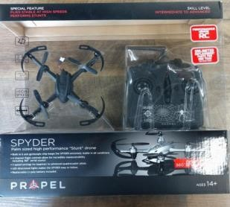 | QC-0950 | MULTI PACK MOTION CONTROL UFO BLUE AND  DARK GREY | 5712 | 5712
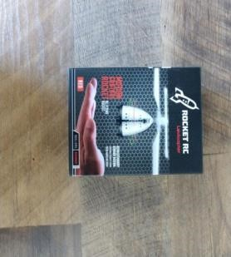 | QC-0951 | ROCKET RC LEVICOPTER RED/SILVER | 5694 | 5694
 | QC-0958 | AIR CRAWLER RED | 1056 | 1056
 | QC-0959 | ROCKET RC AIR CRAWLER SILVER | 216 | 216

 | CD-0585 | CANIDATE PENS 32CT(80MC/PLT) |  | 694048
 | SC-2053 | One Click | 60 |  | 60
 | SL-1814 | VIDEO TALKER | 49 |  | 49
 | SL-1815 | SL-1815 PDQ | 532 |  | 532
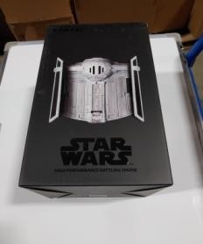 | SW-0327-CX | STAR WARSTIEFIGHTER DRONE | 1629 | 1619 | 10
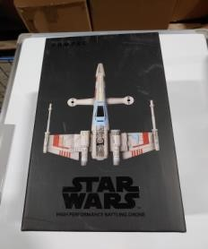 | SW-1977-CX | STAR WARS BATTLING XWING DRONE | 1561 | 1550 | 11
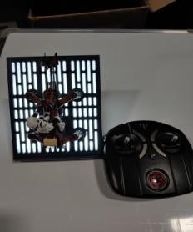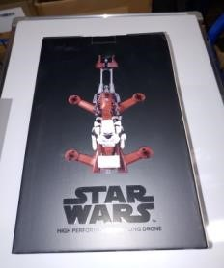 | SW-1983-CX | STAR WARS SPEEDER BIKE DRONE | 2215 | 2208 | 7
 | TK-0530 | CST TANK | 408 | 408

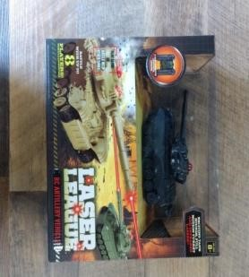 | TK-0534 | TANKS | 1359 | 1359
 | TK-0543 | TANKS | 1608 | 1608
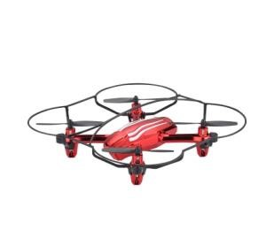 | VL-3540 | MAXIMUM X03 STUNT DRONE | 15054 |  | 15054
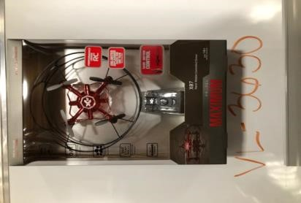 | VL-3630 | MAXIMUM MOVE DRONE RED/BLACK | 20945 |  | 20945
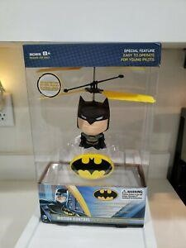 | WB-4001 | BATMAN | 272 | 272
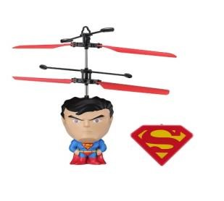 | WB-4002 | SUPERMAN | 13 | 8 | 5
 | WB-4003 | MOTION CONTROL RC FLYING  BATMAN/SUPERMAN | 1582 | 1582
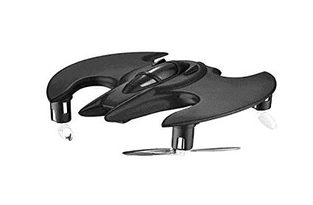 | WB-4010 | BATMAN MICRO DRONE | 7491 | 520 | 6971

